Nonlinear spatial filter
Code:
import cv2
import matplotlib.pyplot as plt
ayi_image = cv2.imread("ayı.jpg")
if ayi_image is None:
exit()
ayi_image_rgb = cv2.cvtColor(ayi_image, cv2.COLOR_BGR2RGB)
median_filtered_image = cv2.medianBlur(ayi_image_rgb, 5)
plt.figure(figsize=(12, 6))
plt.subplot(1, 2, 1)
plt.imshow(ayi_image_rgb)
plt.axis("off")
plt.subplot(1, 2, 2)
plt.imshow(median_filtered_image)
plt.axis("off")
plt.tight_layout()
plt.show()
Explanation of the Code:
- Image Loading:
  - The image ayı.jpg is read using cv2.imread.
  - If the file does not exist, the program exits silently with exit().
- Color Conversion:
  - OpenCV loads images in BGR format by default, so the image is converted to RGB using cv2.cvtColor for accurate visualization in matplotlib.
- Nonlinear Filter Application:
  - A Median Filter is applied using cv2.medianBlur with a kernel size of 5. This nonlinear filter replaces each pixel's value with the median of the neighboring pixel values, effectively reducing noise.
- Visualization:
  - Two subplots are created to display the original and median-filtered images side-by-side for comparison.

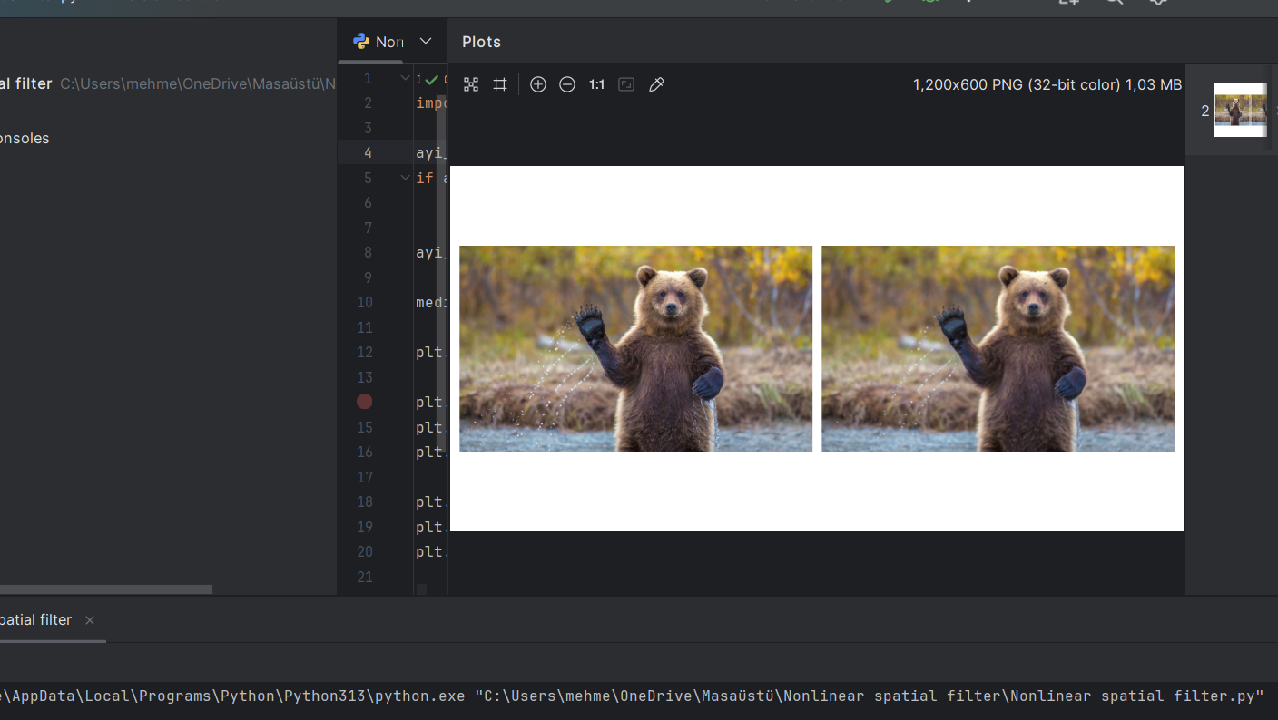
Output:
Report:
Filter Used: Median Filter (Nonlinear)
- Purpose: Reduces noise, particularly "salt-and-pepper" noise, while preserving edges in the image.
- Kernel Size: A 5x5 kernel is used for filtering.
- Results:
  - Original Image: Shows more noise or abrupt intensity variations.
  - Filtered Image: Smoothens noise while maintaining edge sharpness better than linear filters like Gaussian Blur.
The Median Filter is suitable for images with noise where edge details are critical to preserve.

